HCLTech Career Shaper Programme
IV Year Industry Project Report | Academic Year 2026-27
Fake News Detection Using Natural Language Processing (NLP)
TF-IDF, ensemble learning and explainable predictions
Field | Details
Project No. | 31
Domain | Digital-Data-AI / AIML
Format | Individual project (1 learner)
Learner name | Baibhav Pandey
Learner ID / Batch | ABES_JAS26_Digital(AIML)_Batch02
Mentor | Mr. Shivansh Mehta
Submission date | 26-10-2026

Ethical Compliance Declaration
I hereby declare that this project report and the accompanying work are my own, that all data used are either synthetic or used with permission and in accordance with the programme guidelines, and that all external sources have been acknowledged. I understand that fake news detection models can be misused for censorship and I undertake not to use this model to flag specific political content without human review. I have included a model card describing the limitations of the system.

Signature: Baibhav Pandey Date: 26 October 2026
Name: Baibhav Pandey

Abstract
Misinformation spreads quickly on digital platforms, and manual fact-checking cannot keep pace. This project builds a binary text classifier that labels a news article as REAL or FAKE using classical Natural Language Processing. A news dataset in the format specified by the project brief (article_id, headline, body_text, source, publish_date, label, political_lean) was prepared, cleaned (1220 raw rows reduced to 1185) and explored through five visualisations. Articles were converted into TF-IDF unigram and bigram features and five models were compared: Logistic Regression, Naive Bayes, Linear SVM, Random Forest and a soft-voting ensemble. On a stratified held-out test set of 237 articles the ensemble achieved an accuracy of 0.869, an F1-score of 0.876 and a ROC-AUC of 0.909. Predictions were explained using the learned feature weights and per-article term contributions. The report closes with a model card, an ethical analysis and a plan to extend the system with BERT embeddings and LIME. The data used here are synthetic, so the absolute scores demonstrate the pipeline rather than real-world performance.

Table of Contents
1. Introduction
2. Objectives and Scope
3. Dataset Description
4. Data Cleaning and Pre-processing
5. Exploratory Data Analysis
6. Methodology
7. Results and Evaluation
8. Explainability
9. Error Analysis and Fairness
10. Model Card and Ethical Considerations
11. Conclusion and Future Work
12. References
Appendix A: BERT and LIME extension code

1. Introduction
Fake news is deliberately fabricated or misleading content presented as legitimate journalism. It can influence public opinion, damage reputations and undermine trust in institutions. The volume of online content makes purely manual verification impractical, which motivates automated assistance. Natural Language Processing offers a way to learn linguistic patterns that differ between reliable reporting and sensational or fabricated content, such as emotive wording, unverifiable claims, calls to share and anonymous sourcing.
This project, part of the HCLTech Career Shaper Programme, designs and implements a fake news detection prototype, validates it against measurable performance criteria and documents the results. The solution is intended as a decision-support tool for human reviewers, not an automatic censor.

1.1 Problem statement
Given the headline and body text of a news article, predict whether the article is REAL or FAKE, and explain which words drove the prediction.

2. Objectives and Scope
- Prepare and clean a news dataset in the format given by the project brief.
- Perform exploratory data analysis with at least three visualisations.
- Build TF-IDF features and compare several classifiers plus an ensemble.
- Evaluate with accuracy, precision, recall, F1, ROC-AUC and cross-validation.
- Provide explanations of individual predictions and discuss bias, limitations and ethics.
Scope and constraints: the work uses text only (no images, social-graph or fact-database signals). The source and political-lean columns were deliberately excluded from the model inputs to avoid learning shortcuts about outlets or ideology. BERT embeddings and LIME, listed in the brief, are specified as the next extension step (Appendix A) because they require model downloads that were not available in the build environment.

3. Dataset Description
The dataset follows the schema in the project brief. Because the original dataset.csv was not available, a synthetic news dataset of 1220 articles was generated with the same columns, as permitted by the brief (generation with an AI tool). Articles cover six topics (economy, health, politics, technology, sports, environment) and span 1 January 2024 to 30 September 2025. To avoid an unrealistically easy task, 22% of sentences in each article are written in the style of the opposite class, and about 4% of labels were flipped to mimic annotation noise. About 10% of articles are attributed to an outlet of the opposite credibility type.
Column | Type | Description
article_id | string | Unique article identifier
headline | string | Article title
body_text | string | Full article text
source | string | Publishing outlet (not used as a feature)
publish_date | date | Publication date
label | REAL / FAKE | Target variable
political_lean | left / center / right | Used for fairness analysis only
topic | categorical | Subject area
clean_text | string | Pre-processed model input
word_count | integer | Words in clean_text

A complete, filled-in data dictionary is submitted as data_dictionary.csv.

4. Data Cleaning and Pre-processing
Quality checks found 16 articles with a missing body_text and a number of exact duplicate articles. These were removed, leaving 1185 articles (624 FAKE and 561 REAL), a nearly balanced dataset. The following steps produced the clean_text column:
- Concatenate headline and body text.
- Convert to lower case.
- Remove URLs, digits and punctuation.
- Normalise whitespace.
- Remove English stop-words and build unigram + bigram TF-IDF features (up to 20,000 terms, minimum document frequency 2, sub-linear term frequency) inside the vectoriser.
The TF-IDF vectoriser was fitted on the training split only, so no information from the test set leaked into feature construction. The data were split 80/20 with stratification (948 training and 237 test articles, random seed 42).

5. Exploratory Data Analysis

5.1 Class balance
The classes are close to balanced, so accuracy is a meaningful metric, though precision, recall and F1 are reported as well.
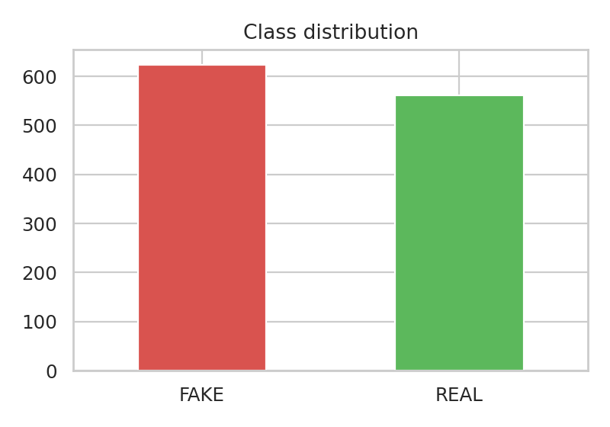
Figure 1: Class distribution (FAKE vs REAL)

5.2 Length and style
Mean article length is similar across classes (78.5 words for FAKE and 75.3 for REAL), so length alone is not a useful signal. Style markers differ clearly: FAKE articles contain on average 2.17 exclamation marks versus 0.79 for REAL articles.
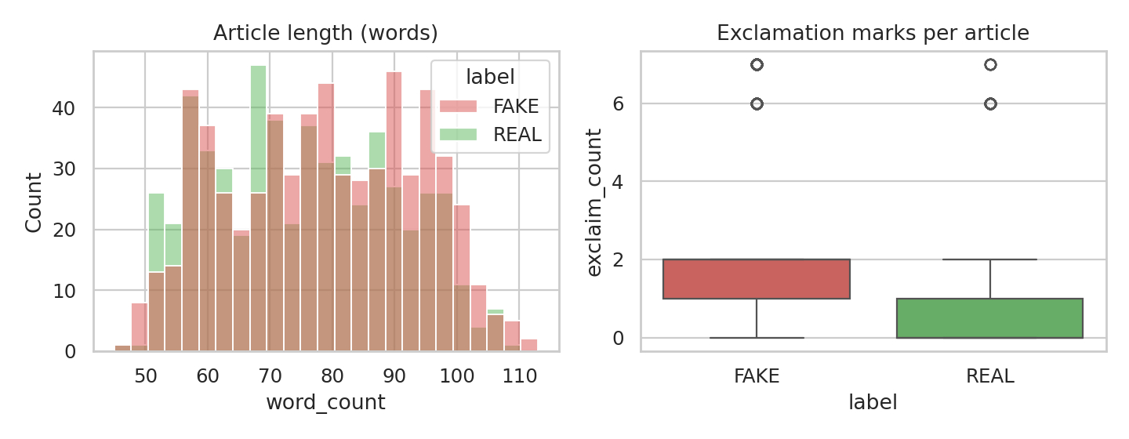
Figure 2: Article length and exclamation marks by class

5.3 Vocabulary
The most frequent non-stop-words show the contrast in language. FAKE articles frequently use sensational and conspiratorial vocabulary, whereas REAL articles favour institutional and reporting vocabulary such as officials, report, committee and review.
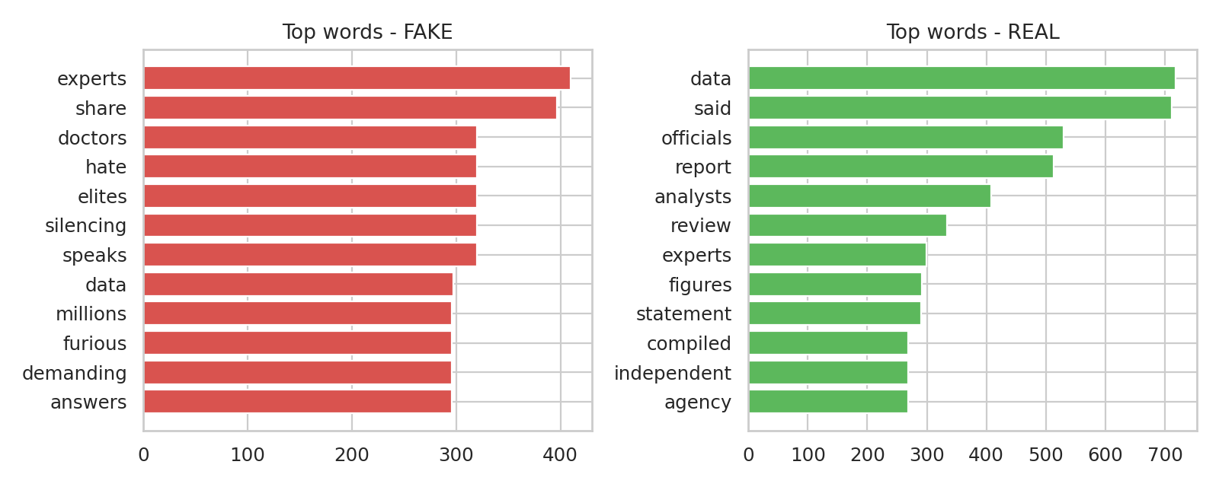
Figure 3: Most frequent words in FAKE and REAL articles

5.4 Political lean and topic
In this dataset FAKE articles are more often labelled right-leaning (49.2% of FAKE articles) while REAL articles are most often centrist (43.9% of REAL articles). This imbalance is an artefact of how the data were generated, but it is exactly the kind of correlation that could cause a model to associate a political orientation with falsehood. For that reason political_lean was kept out of the features and used only in the fairness check (Section 9).
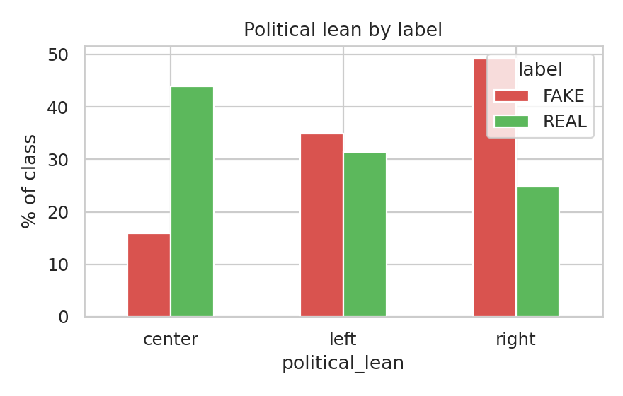
Figure 4: Political lean by label (% of each class)
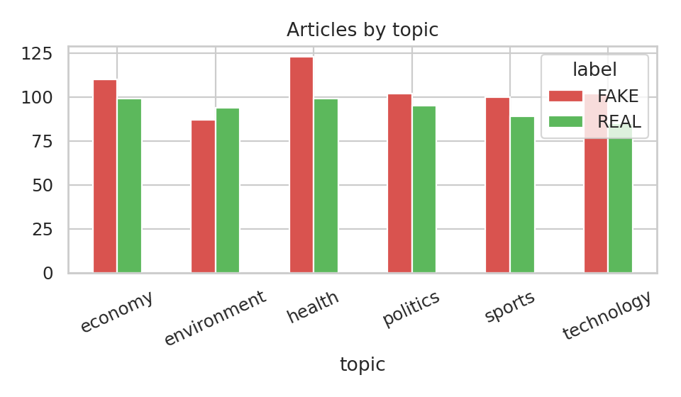
Figure 5: Articles by topic and label

6. Methodology
Five classifiers were trained on the same TF-IDF matrix to allow a fair comparison.
Model | Why it was chosen
Logistic Regression | Strong linear baseline for text; coefficients are directly interpretable
Multinomial Naive Bayes | Fast probabilistic model that works well on sparse word counts
Linear SVM | Maximum-margin linear classifier, often best on high-dimensional text
Random Forest | Non-linear tree ensemble that can capture word interactions
Soft-voting ensemble | Averages predicted probabilities of Logistic Regression, Naive Bayes and Random Forest to reduce variance

Each model was assessed on the held-out test set using accuracy, precision, recall, F1 (FAKE as the positive class) and ROC-AUC. Stability was checked with 5-fold stratified cross-validation on the training data, reporting mean and standard deviation of F1.

7. Results and Evaluation
Model | Accuracy | Precision | Recall | F1 | ROC-AUC | CV F1 (mean ± sd)
Logistic Regression | 0.844 | 0.849 | 0.856 | 0.853 | 0.905 | 0.893 ± 0.015
Naive Bayes | 0.865 | 0.878 | 0.864 | 0.871 | 0.910 | 0.884 ± 0.015
Linear SVM | 0.840 | 0.848 | 0.848 | 0.848 | 0.904 | 0.886 ± 0.011
Random Forest | 0.840 | 0.848 | 0.848 | 0.848 | 0.896 | 0.871 ± 0.011
Ensemble (LR+NB+RF) | 0.869 | 0.873 | 0.880 | 0.876 | 0.909 | 0.891 ± 0.021

The soft-voting ensemble achieved the best F1-score (0.876) and accuracy (0.869), narrowly ahead of Naive Bayes. Differences between the models are small, and cross-validated F1 scores (about 0.87 to 0.89) overlap within one standard deviation, so the ranking should not be over-interpreted. All models reach ROC-AUC of about 0.90 or higher, which indicates that the TF-IDF features carry a strong signal.
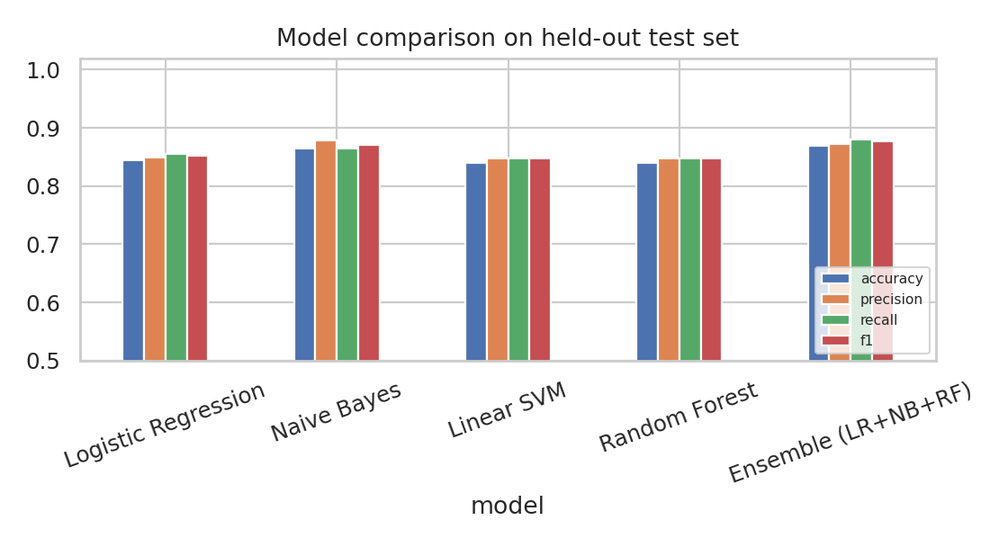
Figure 6: Test-set metrics for all models
The confusion matrix of the ensemble shows that of 112 REAL test articles, 96 were identified correctly and 16 were wrongly flagged as FAKE (false positives). Of 125 FAKE articles, 110 were detected and 15 were missed (false negatives). Errors are therefore spread roughly evenly between the two types.
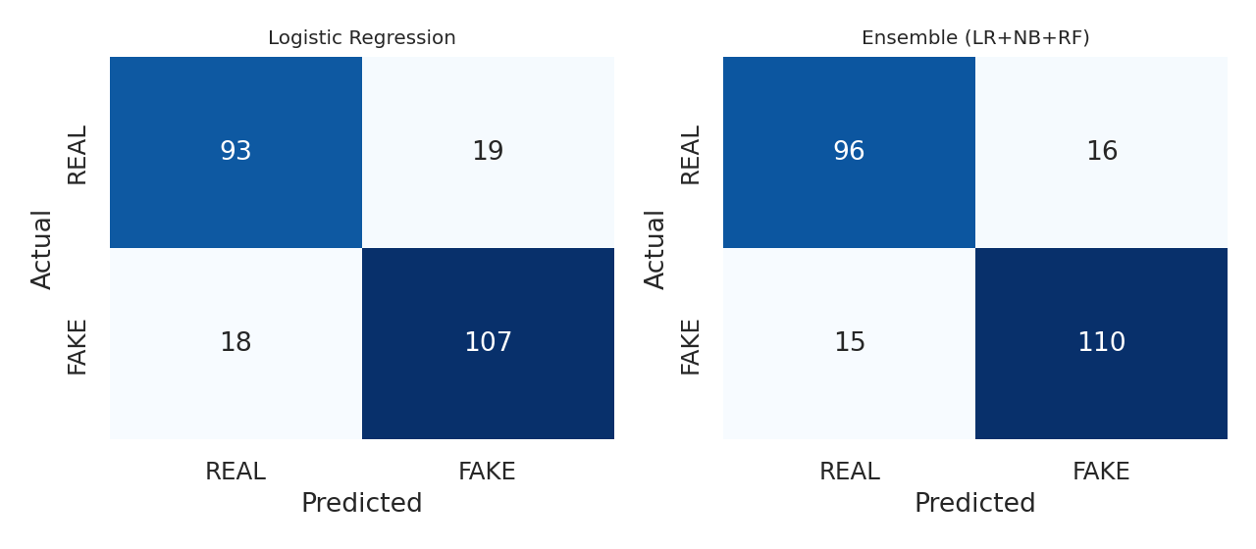
Figure 7: Confusion matrices (Logistic Regression and the ensemble)
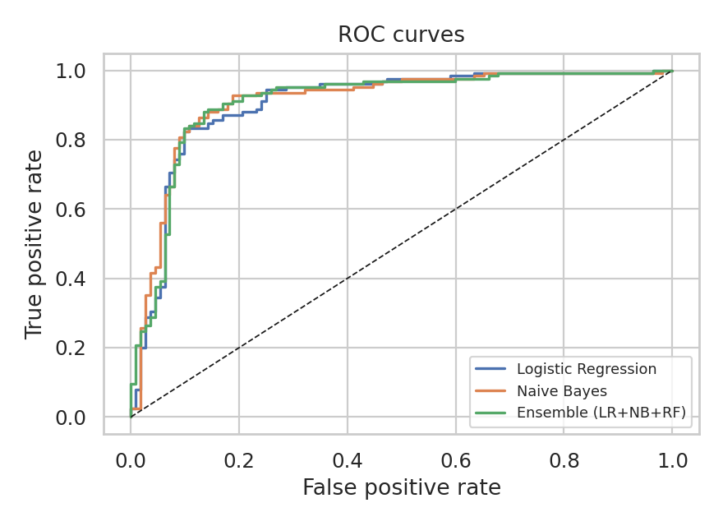
Figure 8: ROC curves

8. Explainability
Trust in a fake news detector depends on understanding why it flags an article. Because the Logistic Regression model is linear, each TF-IDF feature has a weight whose sign shows which class it pushes towards. Figure 9 lists the strongest features in each direction. Features pushing towards FAKE include phrases such as share, experts hate and cover goes; features pushing towards REAL include review, committee, findings and report.
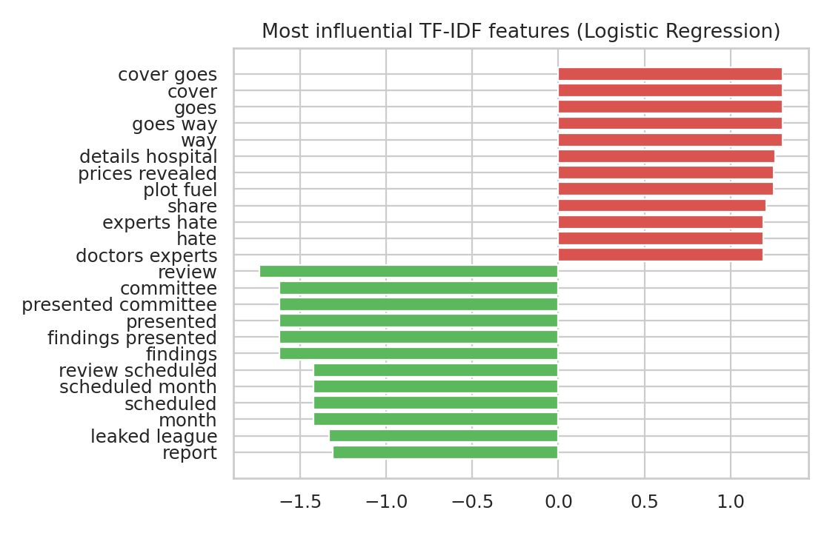
Figure 9: Most influential features (negative = REAL, positive = FAKE)

8.1 Local explanations
Example 1 (sensational text): "SHOCKING: what they are hiding about the housing market will leave you speechless! Share this before it gets deleted." is classified as FAKE with probability 0.783. The strongest contributing terms were share, deleted, gets deleted, gets.
Example 2 (neutral text): "Officials said on 12 March 2025 that inflation is under review. The figures were compiled by an independent agency. Further updates are expected in the coming weeks." receives a FAKE probability of only 0.03. The terms pushing towards REAL were said march, inflation, review, march.
These per-article term contributions (feature value multiplied by coefficient) play the same role as LIME explanations. The brief requests LIME specifically; Appendix A provides ready-to-run LIME code so that the same analysis can be repeated on any prediction in an environment where the library is installed.

9. Error Analysis and Fairness
The best model misclassified 31 of 237 test articles. Manual inspection of the synthetic data explains most errors: articles that mix both styles (for example a neutral opening followed by a sensational closing line) sit near the decision boundary, and about 4% of labels were deliberately noisy, which places a ceiling on achievable accuracy.
Fairness check: the model never sees the political_lean column. However, because FAKE articles in this dataset are more often right-leaning, any model that picked up topic or tone words correlated with lean could unfairly flag right-leaning articles. Before any real deployment, false-positive rates should be measured separately for left, center and right-leaning articles and compared; large gaps would require re-balancing the data or adjusting thresholds. Similarly, the source column was removed because a model that learns outlet names would simply memorise which outlets are labelled fake rather than learn language.

10. Model Card and Ethical Considerations
Item | Details
Model | Soft-voting ensemble (Logistic Regression + Naive Bayes + Random Forest) on TF-IDF unigram/bigram features
Intended use | Decision support for human fact-checkers and editors; triage of articles for review
Out-of-scope use | Automatic removal or blocking of content; flagging individuals or specific political viewpoints; legal or disciplinary decisions
Training data | 1,185 synthetic English news articles (2024-2025); not representative of real-world news
Performance | Test accuracy 0.869, F1 0.876, ROC-AUC 0.909
Known limitations | Text only; English only; no fact-checking against external evidence; vulnerable to style imitation; performance on real news will be lower and must be re-validated
Bias risks | Political-lean and source correlations in the data; topic bias; label noise
Human oversight | All flagged items must be reviewed by a person before any action is taken

Fake news models can be weaponised for censorship. This project therefore treats the classifier as an aid rather than an authority: predictions are probabilities, explanations are shown so reviewers can challenge them, and the model must not be used to flag specific political content without human review. Data used here are synthetic, so no personal data or real publishers are involved.

11. Conclusion and Future Work
A complete fake news detection pipeline was built and evaluated: data cleaning, exploratory analysis, TF-IDF feature engineering, five classifiers, an ensemble, explanations and a model card. The ensemble reached 0.869 accuracy and 0.876 F1 on held-out data, and the explanations show that the model relies on sensational, share-seeking language versus formal reporting language.
Limitations: the dataset is synthetic with templated language, so results overstate what a model would achieve on real news. Future work:
- Replace the data with a real corpus such as LIAR (Wang, 2017) or ISOT and re-evaluate.
- Add BERT sentence embeddings or fine-tune DistilBERT and compare against TF-IDF (Appendix A).
- Use LIME or SHAP for model-agnostic explanations.
- Perform subgroup fairness evaluation and threshold calibration.
- Wrap the model in a REST API and a simple web interface for the demo.

12. References
- Wang, W. Y. (2017). "Liar, Liar Pants on Fire": A New Benchmark Dataset for Fake News Detection. ACL. https://www.cs.ucsb.edu/~william/data/liar_dataset.zip
- Pedregosa, F. et al. (2011). Scikit-learn: Machine Learning in Python. JMLR 12.
- Devlin, J. et al. (2019). BERT: Pre-training of Deep Bidirectional Transformers for Language Understanding. NAACL.
- Ribeiro, M. T., Singh, S., Guestrin, C. (2016). "Why Should I Trust You?": Explaining the Predictions of Any Classifier. KDD.
- HCLTech Career Shaper Programme Guidelines and Project Brief No. 31 (2025-26).

Appendix A: BERT and LIME extension code
The following code was not executed in the build environment (no internet access) and is provided to complete the brief's BERT and LIME requirements when run in Google Colab.
!pip install -q transformers sentence-transformers lime scikit-learn pandas
import pandas as pd, numpy as np
from sentence_transformers import SentenceTransformer
from sklearn.linear_model import LogisticRegression
from sklearn.model_selection import train_test_split
from sklearn.pipeline import make_pipeline
from sklearn.metrics import classification_report
from lime.lime_text import LimeTextExplainer

df = pd.read_csv("dataset.csv")
df["y"] = (df.label == "FAKE").astype(int)
tr, te = train_test_split(df, test_size=0.2, stratify=df.y, random_state=42)

enc = SentenceTransformer("all-MiniLM-L6-v2")
Xtr = enc.encode(tr.clean_text.tolist(), show_progress_bar=True)
Xte = enc.encode(te.clean_text.tolist())
clf = LogisticRegression(max_iter=2000).fit(Xtr, tr.y)
print(classification_report(te.y, clf.predict(Xte), target_names=["REAL","FAKE"]))

# LIME explanation for one article
pipe = lambda texts: clf.predict_proba(enc.encode(list(texts)))
explainer = LimeTextExplainer(class_names=["REAL","FAKE"])
exp = explainer.explain_instance(te.clean_text.iloc[0], pipe, num_features=8)
print(exp.as_list())
exp.save_to_file("lime_explanation.html")

